X-Reserve User Guide

By Pod 1

Table of Contents

1. Introduction 2

Purpose 2

Scope 2

2. System Description 2

Key Features 2

Environment 2

System Components 3

3. Installation 3

Windows 3

Mac OS 3

4. Step by Step Instructions 3

Customers 3

Register new account 3

Edit profile 5

Search available rooms (make sure to mention attributes) 8

Make reservation 12

Staff 16

View Reservations 16

Delete Future Reservations 18

Cancel Future Reservations 19

Edit Reservations 20

Check Out Current Reservation 22

Admin 24

Manage room type 24

Manage room 24

Manage user (Edit profile) 24

Manage user (Create user) 25

Manage chargeable items 25

View reports 25

# Introduction

## Purpose

This document will provide a detailed explanation on how to navigate through X-Reserve and use various features designed for hotel administrators, staff and guests. In addition, it provides a brief introduction about system description and mentions some of key features, system environment and system components.

## Scope

This document provides information on how to install and deploy X-Reserve on Windows and Mac OS. It also explains where different features are located on X-Reserve webpage and how to use them.

# System Description

## Key Features

X-Reserve offers scalable solution for managing hotel reservations regardless of the hotel type. It provides a simple and easy to use interface for guests, hotel managers and hotel staff. Anyone with Internet access a valid credit card can create an account, view available rooms within a date range, and instantly make reservations. The hotel staff can check-in/out a guest and process their bill with only a few clicks. Also, hotel managers can benefit from a wide range of features such as creating rooms, creating accounts with different roles, and viewing yearly or monthly reservation reports.

## Environment

X-Reserve is developed using Spring Framework which is an open source application framework for the Java platform. This enables the product to be compatible with various operating systems such as Mac, Windows and Linux. Although Spring Framework does not provide any specific programming model, it is modular. Spring has layered architecture, meaning that it is possible to use any of it in isolation, and yet its architecture stays consistent. It allows integrations with many modules or applications such as different databases or reporting applications. X-Reserve can easily be deployed and setup in less than an hour. The Controller is responsible for handling requests from the presentation layer.

## System Components

X-Reserve consists of different components or modules to allow scalability of this product. The system is made of three different layers which provide a consistent and reliable architecture. The Controller is responsible for handling requests from the presentation layer (eg. login, view report, view room list). Theses request are passed to DAO (Data Access Object) which lies within the business layer. DAO generates queries based on the user or system request, executes them on the database, and returns the results to the Controller. In addition to these main components, other parts such as security modules and validators provide confidentiality and integrity for the hotels’ data.

# Installation

## Windows

1. Download the latest version of Maven from <http://maven.apache.org/>.

2. Extract and install the downloaded file.

3. From the command-line in the extracted directory run “mvn jetty:run” after setting up environment variables.

## Mac OS

1. Download the latest version of Maven from <http://maven.apache.org/>.

2. Unzip and install the downloaded file.

3. From the command-line in the extracted directory run “mvn jetty:run” after setting up environment variables.

# Step by Step Instructions

## Customers

### Register new account

1. Left clicks “Register” on the top right menu bar to start registering an account.

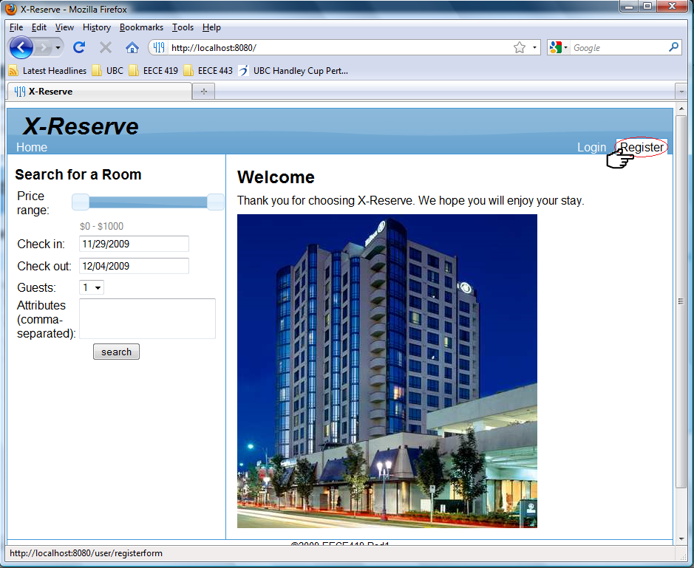

1. In the “User Detail” panel, type the username, password, e-mail, and address.

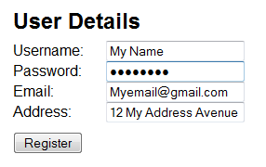

1. Left clicks “Register” to create this account.

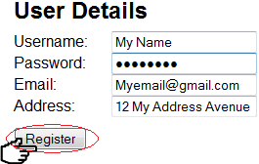

### Edit profile

1. Left clicks “Login” on the top right menu bar to logs into your account.

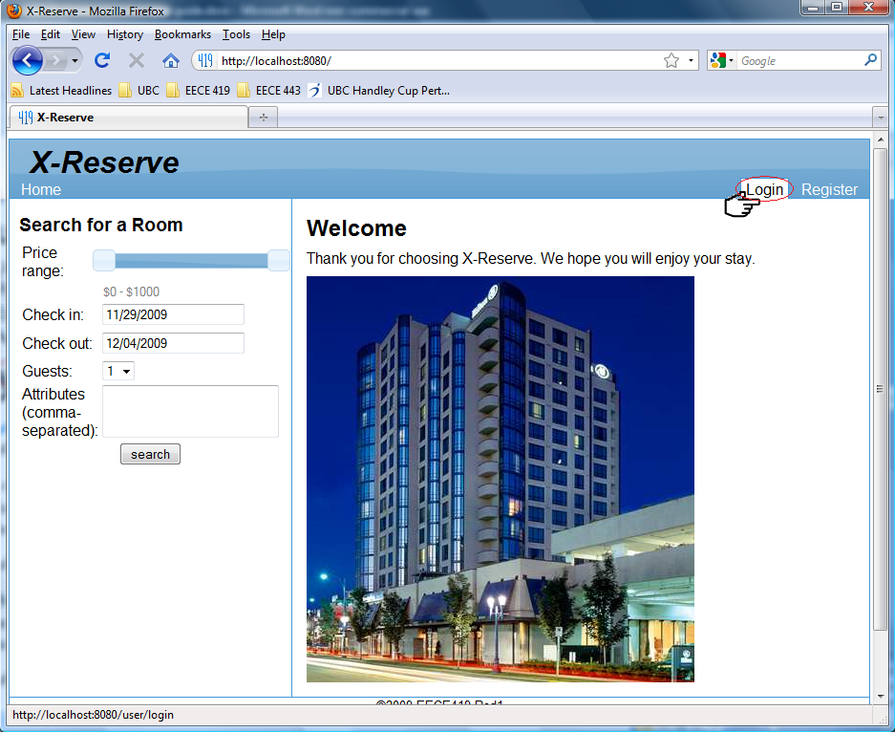

1. In the “Login” panel, enters your username and password.  
   Hint: If you want to save the username and password on this computer, please selects the “Remember me” check box after you enters your username and password.

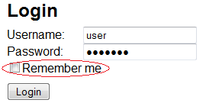

1. Left clicks “Login” to log into your account.

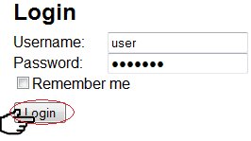

1. After logs in, you will be directed to the homepage of this website. On the top right menu bar, you should be able to see your username. This means that you have successfully logs into the system.

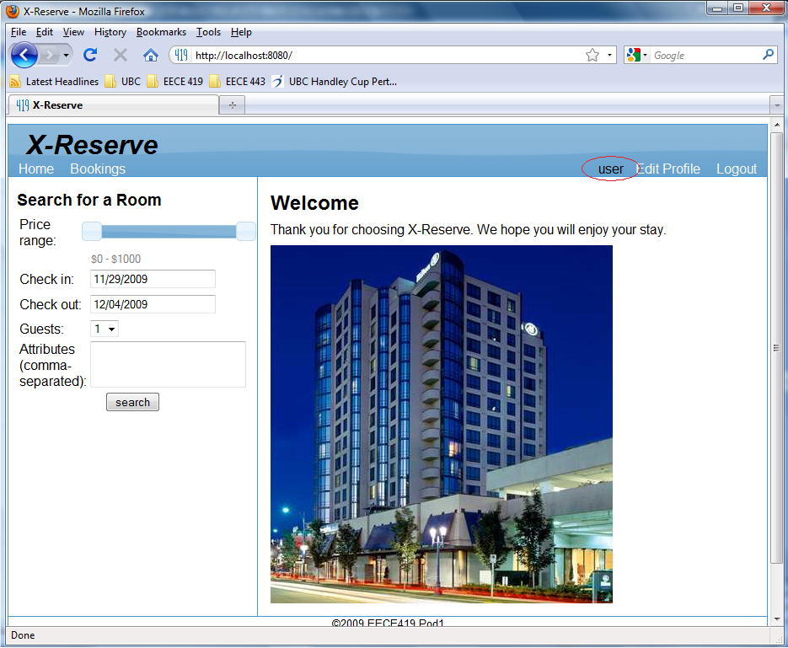

1. Left clicks “Edit Profile” next to your username on the menu bar to start editing your profile.

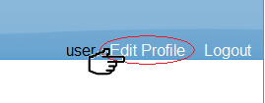

1. Type any new information into the corresponding fields.  
   Hint: Due to security reason, we have hidden your password. If you want to change the password, please just enter the new password in the empty password field. If you do not want to change the password, simply just leave that field empty.

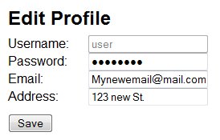

1. Left clicks “Save” to confirm the operation.

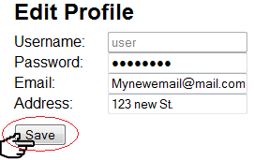

### Search available rooms (make sure to mention attributes)

1. Drags the ranch bar to indicate the price range.

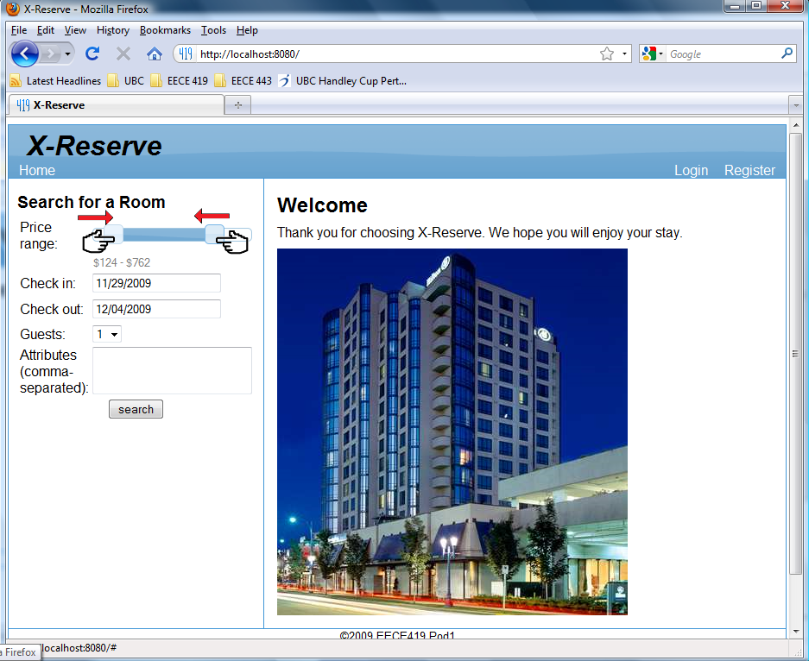

1. Chooses check-in and check-out date.

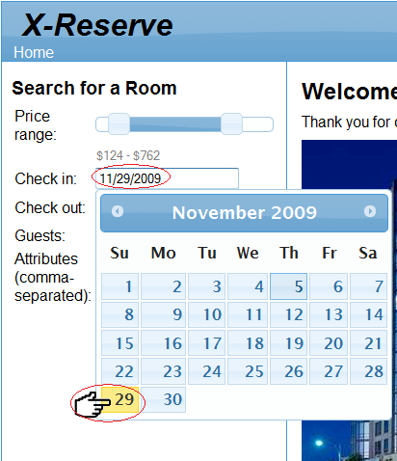

1. Left clicks on the drop down bar to select the number of guests is accompanied.

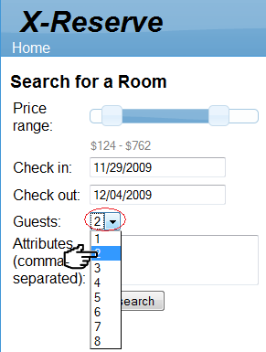

1. Enters attributes and uses comma to separate each attributes. Hint: Direct your mouse cursor on to the “Attributes” to view possible attributes that can be searched.

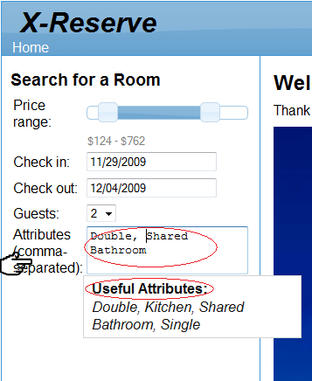

1. Left clicks “search” to start the search operation.

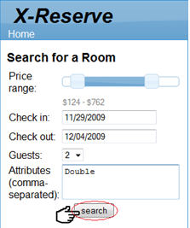

1. After searching, the system will display the result of all the available rooms that you have requested.

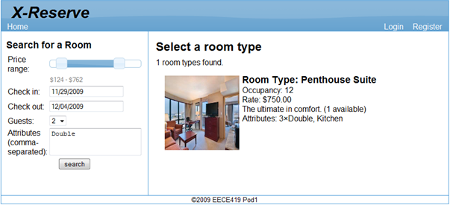

### Make reservation

1. After searching the available rooms using the “search available rooms” operation, the system will display the result of all the available rooms that you have requested.

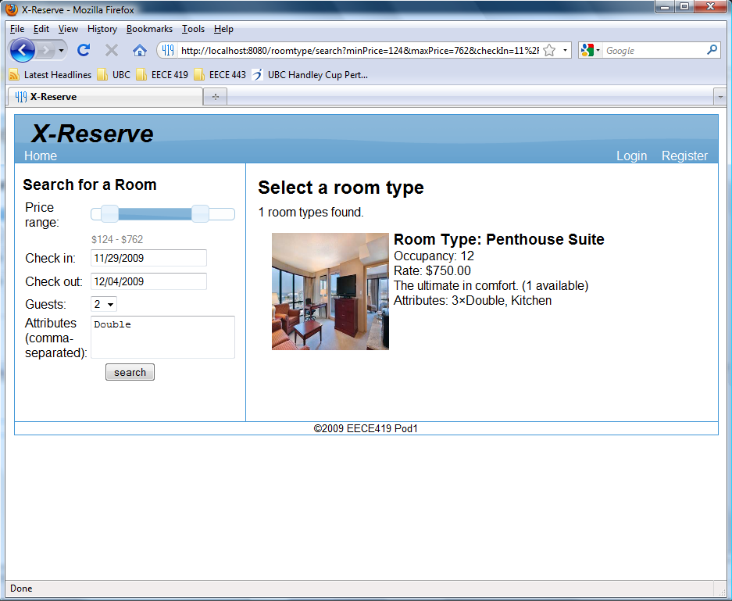

1. Finds the available room that you would want to reserve and moves your cursor to the right bottom corner of the available room, and then a “Reserve” link will pop out. Left clicks “reserve” to reserve the room.

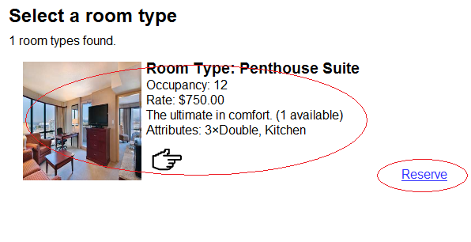

1. Left clicks “Reserve” to reserve the available room.

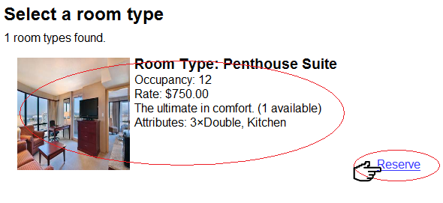

1. The system will direct you to the login page requesting you to log into your account in order to perform the reservation process.

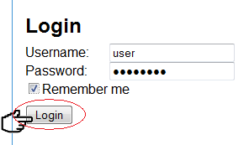

1. Entering your username and password then left clicks “Login” to start reservation process.  
   Hint: If you do not have an account, please register an account by following the procedure from the manual (Register new account).
2. Enters the payment information

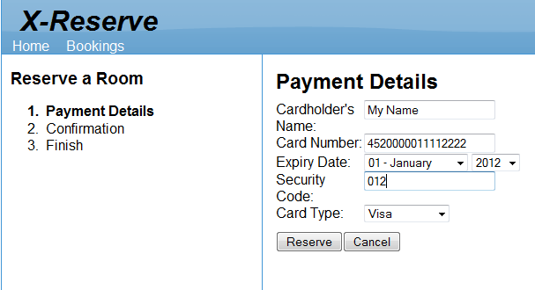

1. Left clicks “Reserve” to confirm the operation

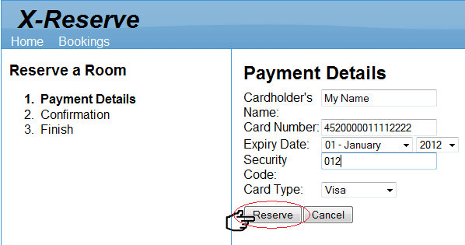

1. They system will print out the reservation information. Left clicks “Reserve Room” to reconfirm the operation is correct.

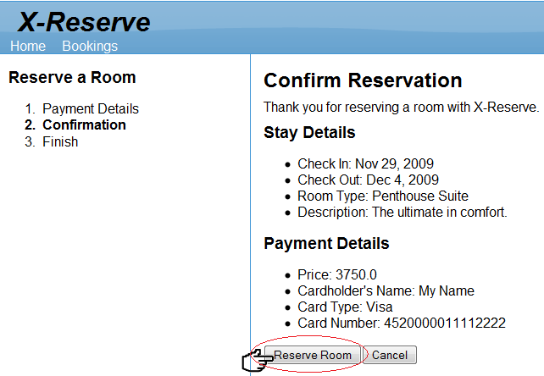

1. The reservation is complete.

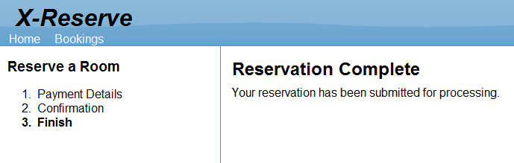

## Staff

### View Reservations

1. Left clicks “Login” on the top right menu bar to logs into your account.



1. In the “Login” panel, enters your username and password.  
   Hint: If you want to save the username and password on this computer, please selects the “Remember me” check box after you enters your username and password.

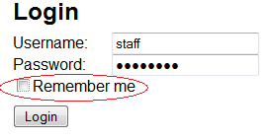

1. Left clicks “Login” to log into your account.

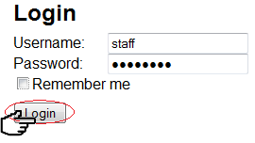

1. After logs in, you will be directed to the homepage of this website. On the top left menu bar, you should see a link to “Reservations”. Left clicks “Reservations” to view your reservation or to check-in / check-out the room.

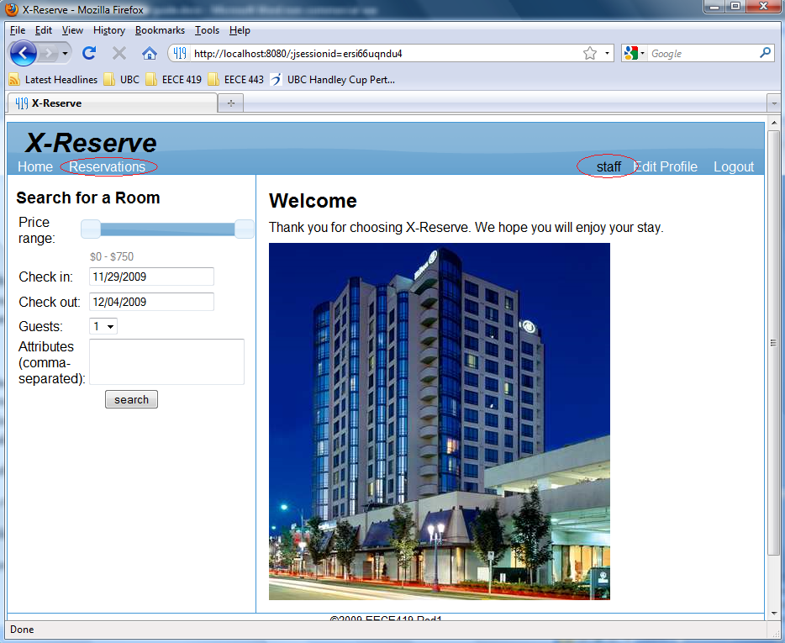

1. The system displays all reservations.   
   Hint: if you would like to view past or current or future reservations, you can filter it using the drop down menu provided.

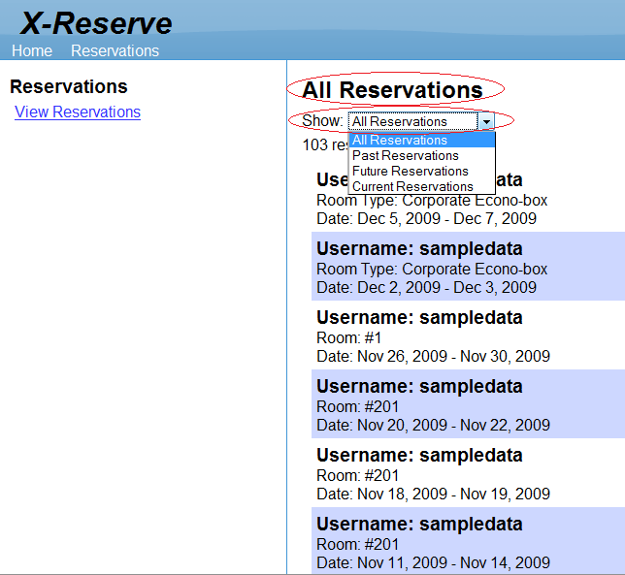

### Delete Future Reservations

1. Place mouse cursor on a selected future reservation to view options.

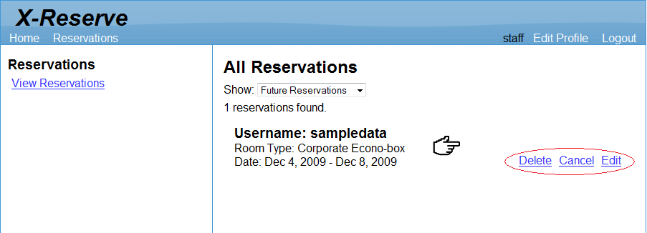

1. Left click “Delete” to remove the selected future reservation.

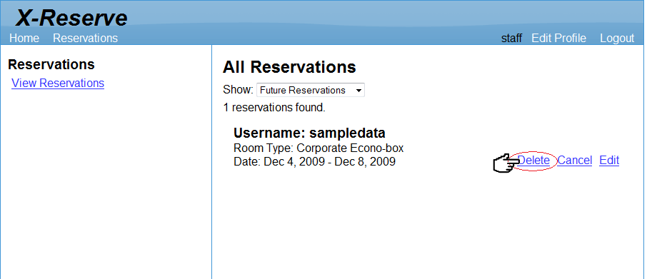

1. The selected future reservation is removed from the list.

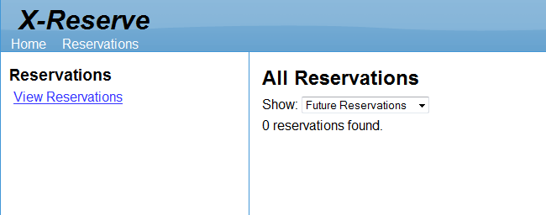

### Cancel Future Reservations

1. Place mouse cursor on a selected future reservation to view options.



1. Left click “Cancel” to cancel the selected future reservation.

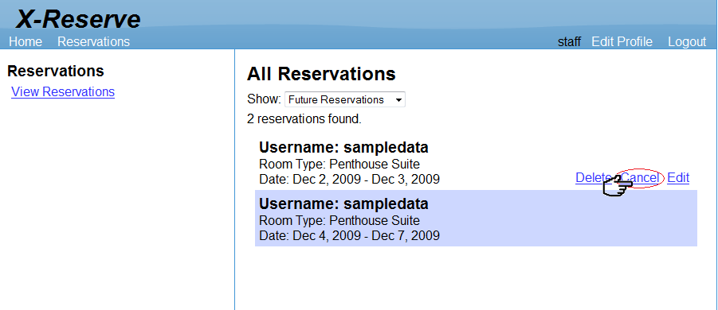

1. The selected future reservation is cancelled and system displays the corresponding cancellation fee.

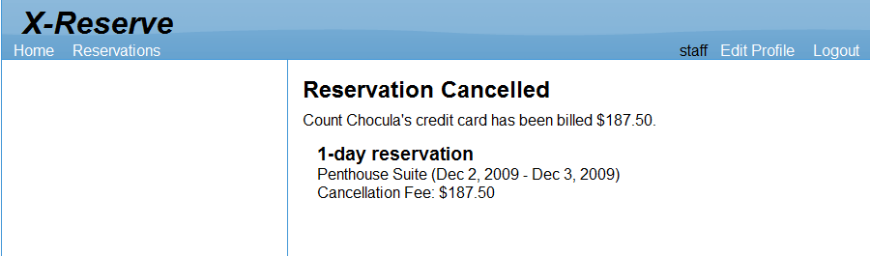

### Edit Reservations

1. Place mouse cursor on a selected current or future reservation to view options.



1. Left click “Edit” to edit the selected reservation.

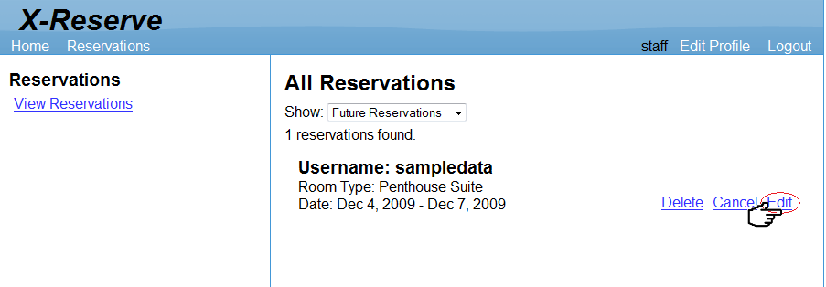

1. The system will display reservation details. The staff can change the price by changing the value in the “Quoted Price” field and add chargeable item by clicking on the provided link.

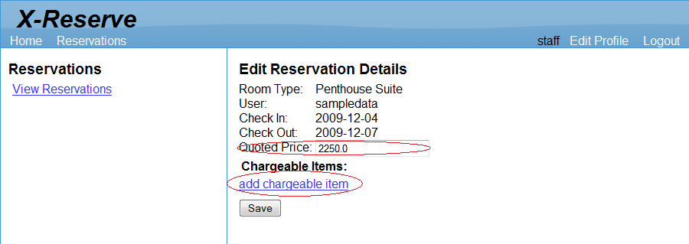

1. Left click “add chargeable item” to add chargeable item. System will display options to add standard chargeable item or custom chargeable item. Left click the standard chargeable item to add it to the selected reservation or add custome chargeable item by providing the name, price, and SKU of a custom chargeable item. Left click “Save” to add the custom chargeable item.

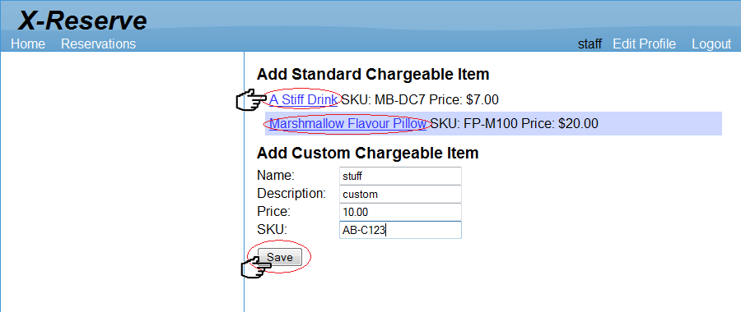

1. The chargeable item will be added to the reservation details. Left click “Save” to save the changes made to the reservation.

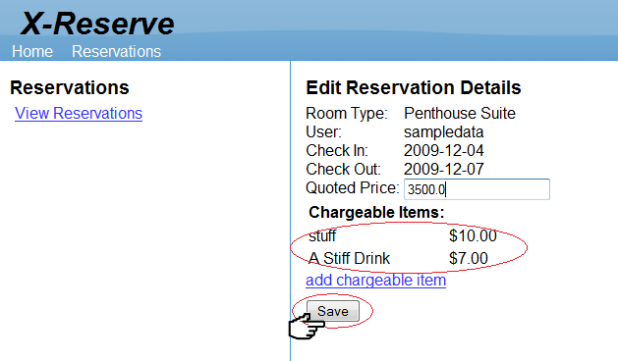

### Check Out Current Reservation

1. Place mouse cursor on a selected current reservation to view options.

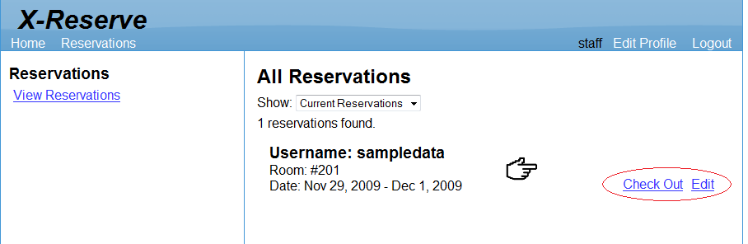

1. Left click “Check Out” to check-out the selected current reservation.

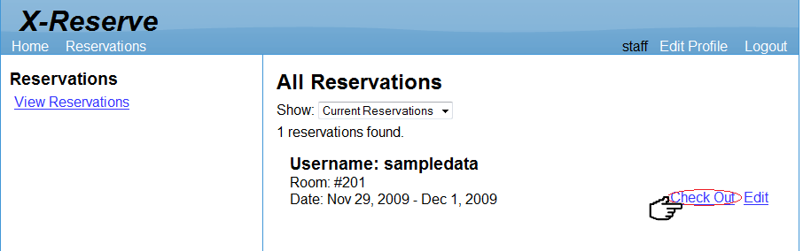

1. The selected reservation has been checked-out and the system will display a summary of the reservation.

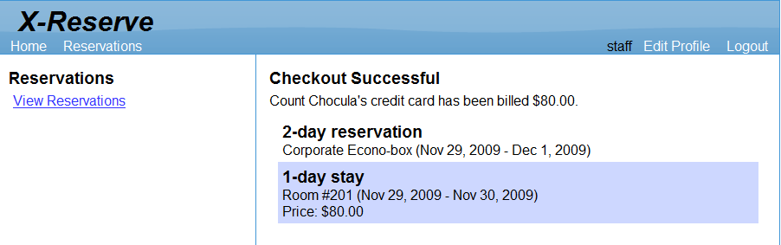

## Admin

### Manage room type

* 1. Left click “Rooms” on the top menu bar to start managing room types

Hint: If you want to view all the existing room types instead of creating a new room type, left click “View Room Types” on the left menu bar to view all the existing room types. (All the room type information will be displayed in the main panel, including the pictures of the room types). If you want to modify an existing room type, you can move your mouse to the room type and a “Delete” and a “Edit” options will be appeared. Choosing “Delete” will delete the room type and selecting “Edit” will allow you to modify the room type.

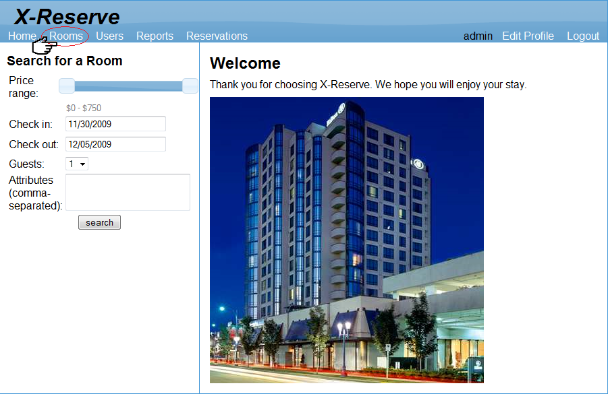

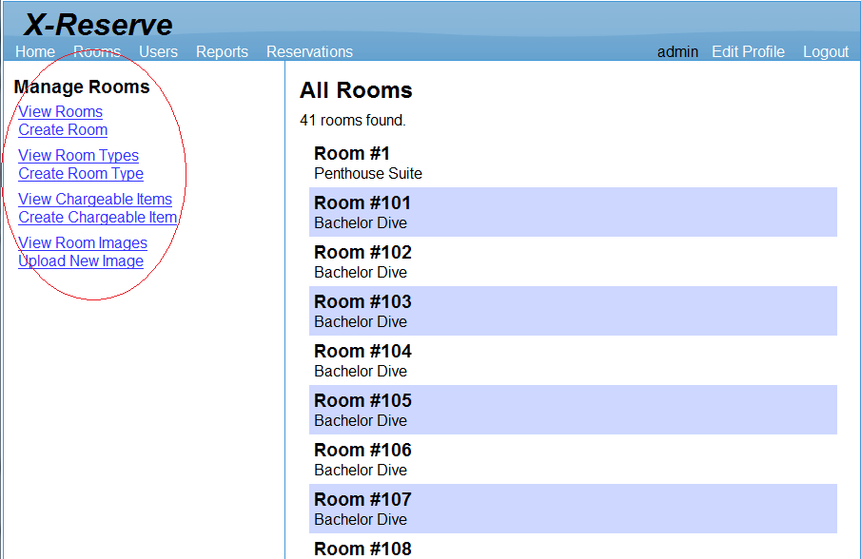

* 1. Left click “Create Room Type” on the left side bar to create a new room type

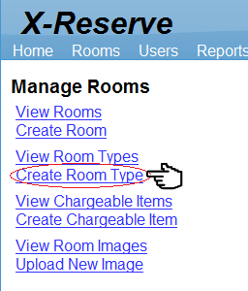

* 1. In the “Edit Room Type Detail” panel, type the room type name, description, daily rate, maximum occupancy and search attributes

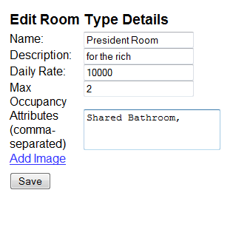

* 1. If you want to add an image to the room type, left click the “Add Image” link, and then choose one from a list of pictures

Hint: After adding an image, if you want to change the image, you can simply left click the “Change Image” link and then choose a new picture

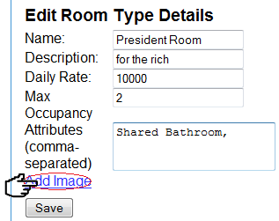

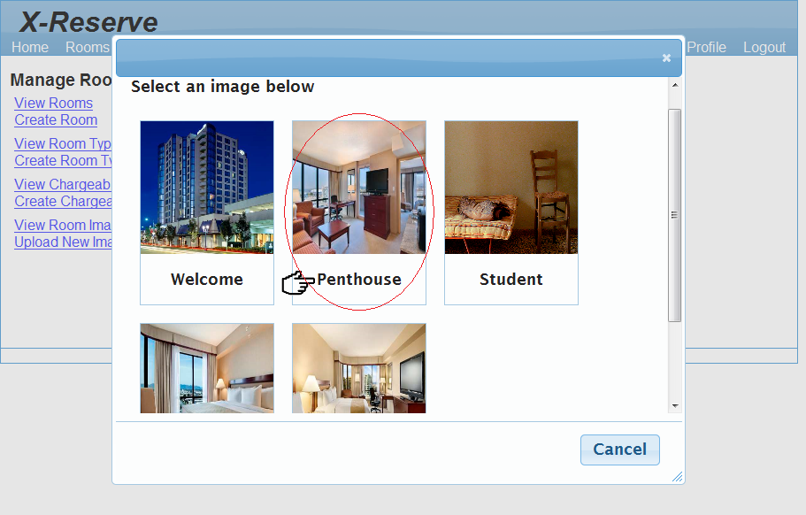

* 1. Left click “Save” to create this new room type

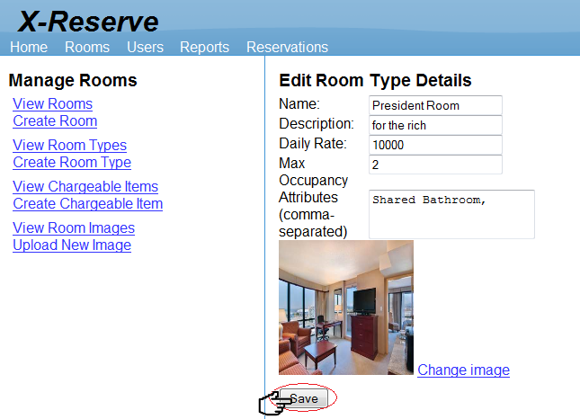

* 1. After creating a new room type, you will be able to see your newly created room type plus all the existing room types

### Manage room

1. Left click “Rooms” on the top menu bar to start managing room types

Hint: If you want to view all the existing rooms instead of creating a new room, left click “View Rooms” on the left menu to view all the existing rooms. (All the room information will be displayed in the main panel). If you want to modify an existing room, you can move your mouse to the room and a “Delete” and an “Edit” options will be appeared. Choosing “Delete” will delete the room and selecting “Edit” will allow you to modify the room.



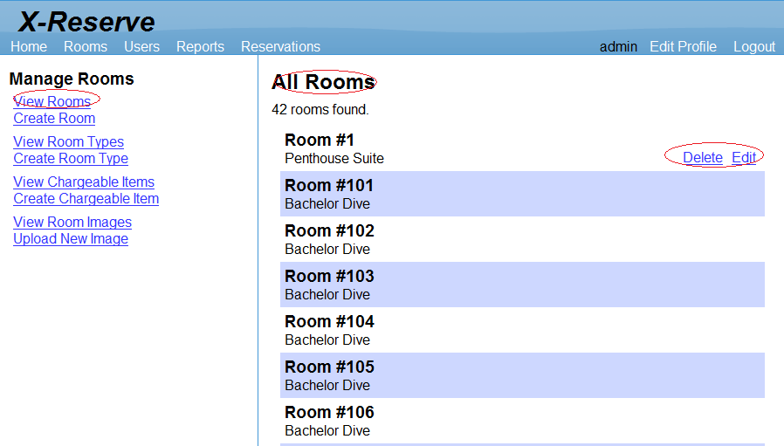

1. Left click “Create Room” on the left side bar to create a room

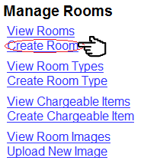

1. In the “Edit Room Detail” panel, type the room number and select a room type for the room

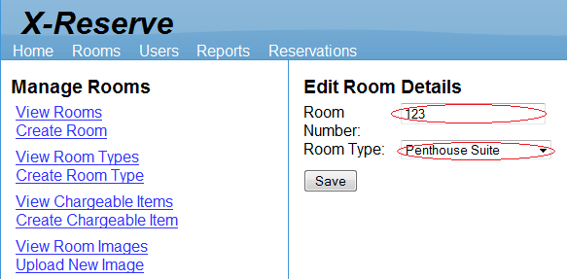

1. Left click “Save” to create this new room

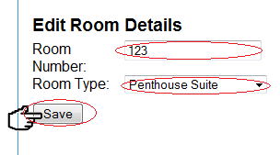

### Manage user (Edit profile)

1. Left click “User” on the top menu bar to start managing users

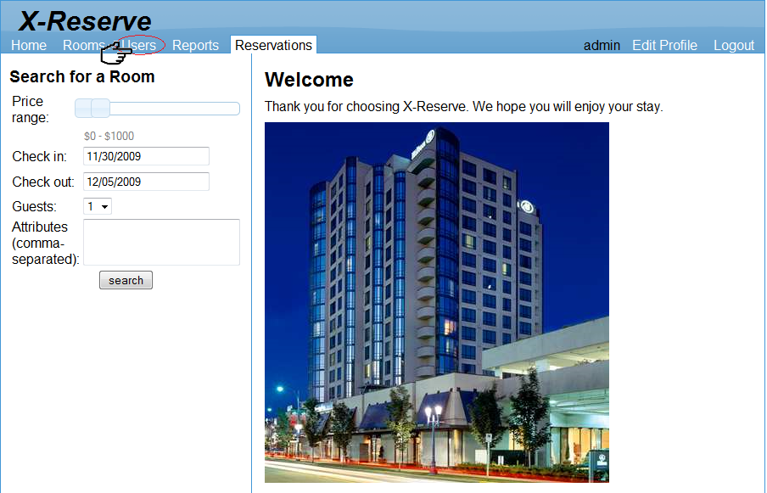

1. If you want to edit your own profile, left click the “Edit Profile” on the left side bar to modify your own profile

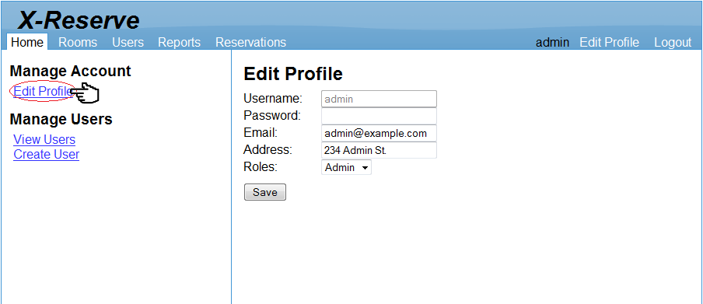

1. Type any new information into the corresponding fields

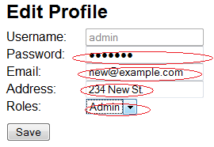

1. Left click “Save” to confirm the operation

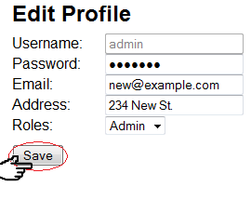

### Manage user (Create user)

* + 1. Left click “User” on the top menu bar to start managing users

Hint: If you want to view all the existing users instead of creating a new user, left click “View Users” on the left menu to view all the existing users. (All the users will be displayed in the main panel). If you want to modify an existing user, you can move your mouse to the user and a “Delete” and an “Edit” options will be appeared. Choosing “Delete” will delete the user and selecting “Edit” will allow you to modify the user.



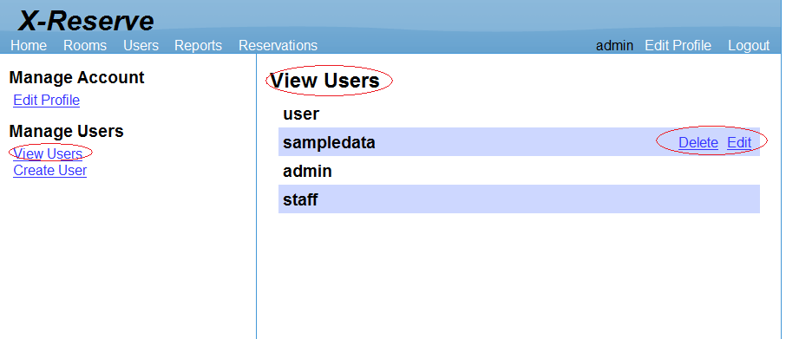

* + 1. Left click the “Create User” on the left side bar to create a new user

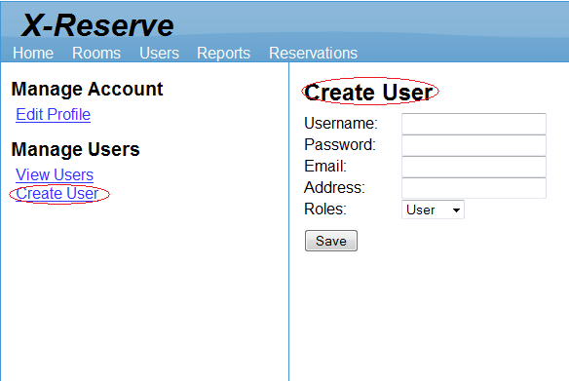

* + 1. In the “Create User” panel, type the customer username, password, email, address and select a role for the user.

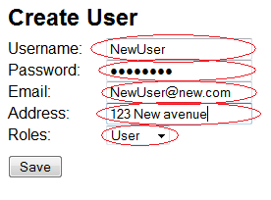

* + 1. Left click the “Save” button to create this new user

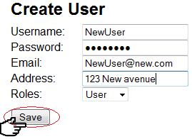

### Manage chargeable items

* + - 1. Left click “Rooms” on the top menu bar to start managing room types

Hint: If you want to view all the existing chargeable items instead of creating a new chargeable item, left click “View Chargeable Items” on the left menu to view all the existing chargeable items. (All the chargeable item information will be displayed in the main panel). If you want to modify an existing chargeable item, you can move your mouse to the chargeable item and a “Delete” and an “Edit” options will be appeared. Choosing “Delete” will delete the chargeable item and selecting “Edit” will allow you to modify the chargeable item.



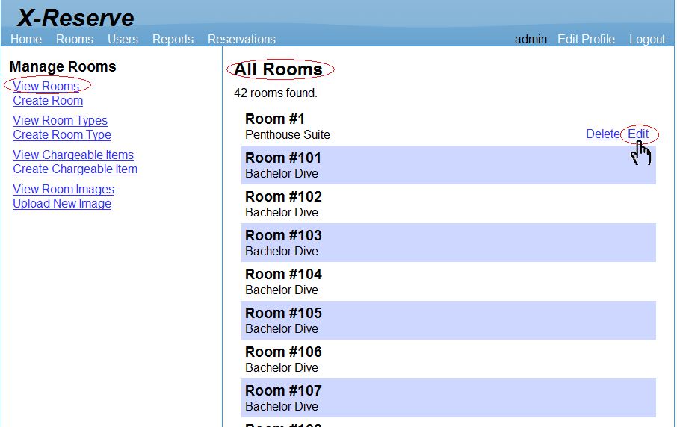

1. Left click “Create Chargeable Item” on the left side bar to create a new chargeable item

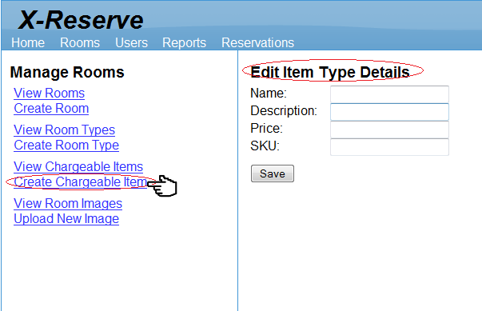

1. In the “Edit Item Type Detail panel, type the item name, description, price and SKU

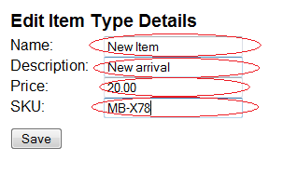

1. Left click “Save” to create this new chargeable item

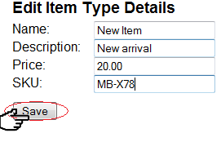

### View reports

1. On top of the page, left clicks “Reports” link to view report.

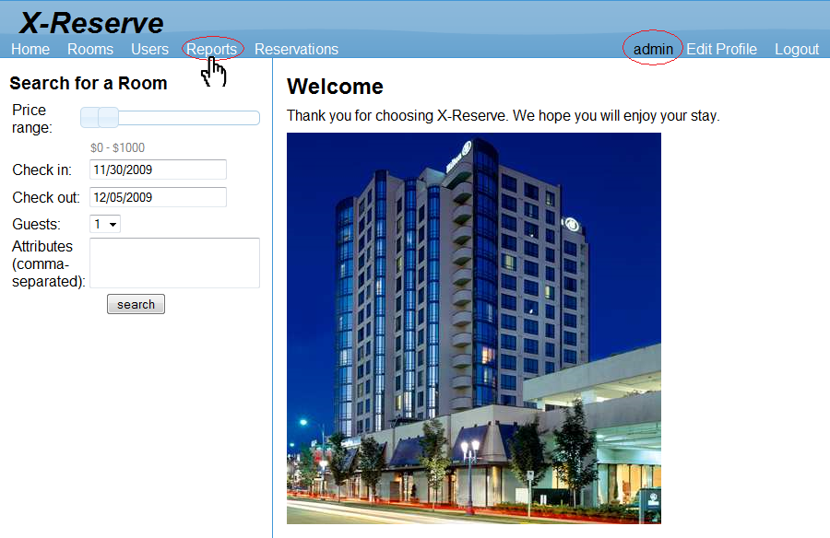

2. On the left side of the page, selects the year you would like the report to be generated for.

